ST. ANNE SCIENCE FAIR
JANUARY 24-26, 2020

All St. Anne 8th graders carry out a science fair project, which will be judged and shown at the science fair the weekend before Catholic Schools Week at the end of January or the beginning of February.

The science fair project is a way for you to explore a topic in science that interests you by using the scientific method. Each section of this handout describes what you will do for one step of the scientific method or for one step of your science fair project. Each section also tells you when the rough draft for that part is due and how many points it is worth. The entire science fair project is worth 300 points—15 points during the 1st quarter, 125 points during the 2nd quarter, and 160 points during the 3rd quarter.

Here are the steps of the scientific method.
- Ask a question, or state the problem (your topic).
- Gather information (research paper & bibliography).
- Form a hypothesis.
- Test the hypothesis (the experiment; including materials, procedure, and data).
- Analyze the data. (This includes tables, graphs, pictures, calculating percentages, calculating means, etc.)
- Make conclusions.
- Decide to accept the hypothesis if the data support it. Decide to reject the hypothesis if the data do not support it. (Your decision is included in the conclusion section of the report.)
- If your hypothesis is accepted, you may design other experiments to test it further. If your hypothesis is rejected, you must modify it or throw it out and form a new hypothesis. Then go back to step 4. (This will also be included in the conclusion section of the report.)
- Report the results. This could be a student’s lab report, a student’s science fair display and report, or a scientist’s paper in a scientific journal (a journal is what scientists call a scientific magazine).

The entire science fair written report should be written in 3rd person. That means you do not use these pronouns: I, me, my, mine, we, us, our, ours, you, your, or yours. The final report should be typed double-spaced in Times New Roman size 12 font, with 1-inch margins. The final report should not have your (or anyone else’s) name or homeroom anywhere, or any photographs in which the people can be identified; the only identification will be the science fair number that will be assigned to you. However, all the rough drafts that are due before January should have your name and homeroom on them.

Due dates and points for each section of the 2020 St. Anne science fair project.
All parts may be turned in sooner than the due date except the final display.

SECTION DUE DATE POINTS POSSIBLE

1ST SEMESTER

Topic + short description 10/4/19 15
(the problem or question)

Order Form for Display Board 11/8/19 ---

Research Paper 11/15/19 50

Bibliography 11/15/19 15

Hypothesis 11/25/19 15

Materials 12/13/19 20

Procedure 12/13/19 25

Total: 140

2ND SEMESTER

Daily Log 1/24/20 20

Science Fair written report 1/24/20
- Title Page, Table of Contents, corrections made to 10
already-graded parts
- Data & Analysis 20

- Conclusions 20

Display 1/24/20 75

Abstract 1/24/20 10

Overall Format 1/24/20 5

Total: 160

+ up to 5 points of Extra Credit

SCIENCE FAIR
Step 1 of the Scientific Method

ASK A QUESTION OR STATE THE PROBLEM (choosing your topic)

Please do not work any further on your science fair project until I have approved your topic.

You will decide what you want to explore and test for your science fair project. If you don’t know what you’d like to do, here are some resources to help you. There are some books of science fair project ideas in the science classroom which you may use during free time or which you may check out for 2 days at a time. However, it may be easiest to search “science fair project ideas” on a computer.

Start with things that interest you. For example, if you really like gardening, you may want to choose a topic that involves growing flowers or vegetables under different conditions. If you are interested in magnetism, you may want to study the effect of magnets on different objects or how different conditions affect the operation of magnets. However, remember that the topic needs to be testable using the scientific method. So you will have to be able to form a hypothesis and design an experiment to test it. You will also need to make sure that all the equipment and supplies you need are readily available to you.

If you want to use or do anything potentially hazardous, I will need written permission from a parent, a written guarantee from your parent that he/she—or another responsible adult designated by your parent—will supervise anything hazardous, and an explanation of how the person supervising you is qualified in that area. If you are using any people under 18 years old (other than your own siblings), you will need written permission from their parents. I will give you any permission forms you need.

If the topic you want will cause harm or terror to any animal (and that includes even “bugs” and worms), I will not approve it.

Your requested topic is worth 15 points and it is due on Friday, October 4, 2019, at the latest, but you may turn it in earlier. If more than two students request a particular topic, I will use the date that you turn in your topic to help me determine who will be approved for that topic.
Your topic request should be written in 3rd person. It also must include a brief description of what you think you want to do in your experiment so that I know you’ve thought it through. So, don’t just say, “The effect of water on plants will be tested.” Instead, say, “The effect of water on plants will be tested by giving different plants different amounts of water, and then measuring plant height after 2 weeks.” If your planned experiment changes after your topic is approved, that’s O.K. If you want to change your entire project, you need to ask me for approval again.
If you think you may want to enter your project in the regional Science Fair at Cobo Hall, using any vertebrate animals (including humans), bacteria, mold, or hazardous substances will require extra paperwork BEFORE doing the experiment.
SCIENCE FAIR

THE DAILY LOG—in the composition notebook

The daily log (similar to a journal or diary of your science fair project) is recorded in your composition notebook. The outside cover should have your assigned ID number; your name should NOT be written anywhere. Number the pages so you can make a table of contents. You may write on only the front of each page or on the front and back, whichever you prefer. The entries do not need to be in cursive; although others may read them, they are mainly for you.

Write these things in your daily log as they are approved by your teacher or as you do them:
Each page should have the page number, the title at the top (what is on that page), and the date on which that section was approved by the teacher or the date on which those data were recorded.
On page 1—the Table of Contents
p. 2—Question or Problem (your topic)
p. 3-?—Research. Write notes about what you read and learn when you do the research for the research paper. Include all the information you can find about each source to put into your bibliography (author, title, date, publisher, web address, page numbers).
p. ?—Hypothesis
p. ?—Materials (may need more than 1 page)
p. ?—Procedure (may need more than 1 page)
p. ?-?—Data. This section includes ALL the data, even if it’s something you decide not to include in the final report—everything you describe, measure, draw, observe, photograph, etc. It should also include what you think, what went “wrong,” any corrections or changes you make, etc. Every day that you collect data should be dated, and even times if the time is important. This section will probably be the longest section of your daily log.
p. ?-?—Data Analysis—In this section, you organize your data so that it can be easily understood by you and by readers. It includes calculations, tables, graphs, interpretations, etc.
p. ?—Conclusions—Make conclusions in which you decide whether your hypothesis was supported or not supported by the data, and therefore whether you accept or reject the hypothesis. Decide whether errors may have affected your results, try to explain why what happened did happen, and how you might re-test your hypothesis (if it was accepted) or modify your hypothesis (if it was rejected).

The daily log will be placed on the table in front of your display. It is due the same day as the final science fair project, Friday, 1/24/20, and is worth 20 points.

Your ID number will be written or typed on the cover page of the science fair report, on the display board, on the abstract, and on the cover of the composition notebook.

My science fair ID number = ____________

See back for explanations and samples of daily log entries.
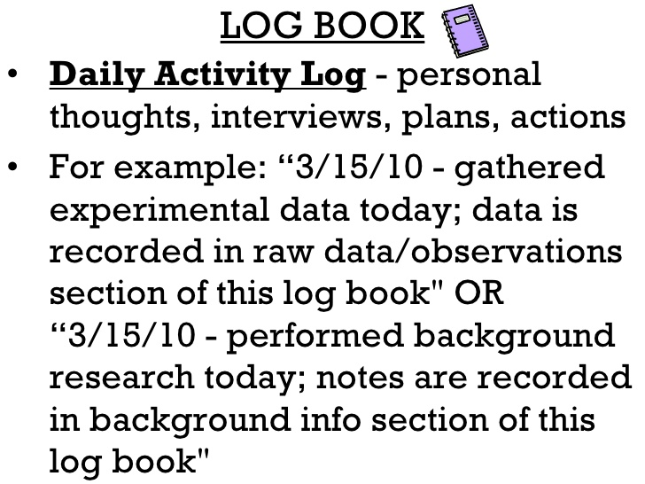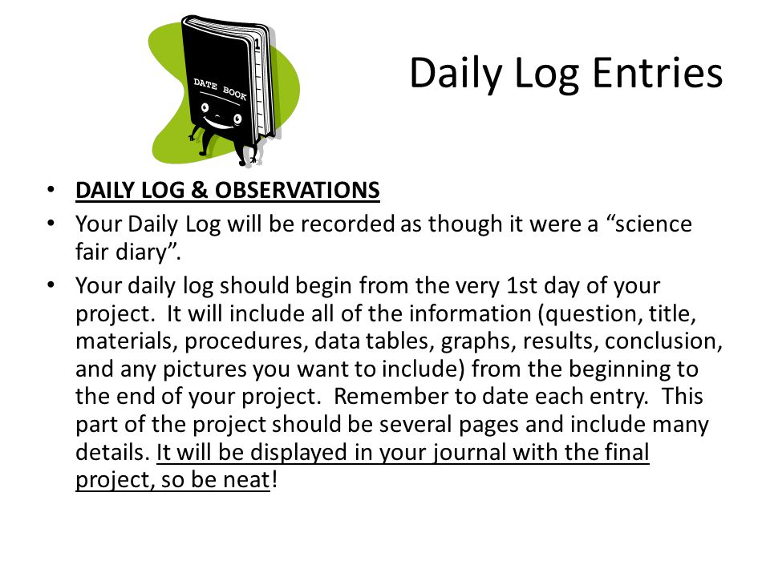

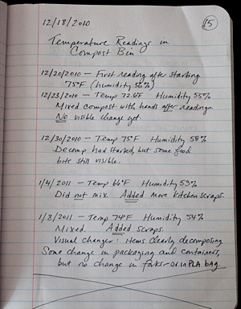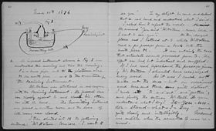
SCIENCE FAIR
Step 2 of the Scientific Method

GATHER INFORMATION (do research and write a research paper with bibliography)
Once your science fair topic has been approved, you must find out what is already known about it. Then you can develop a hypothesis to test some aspect that is still unknown. In contrast, you can test something that has already been tested in order to confirm it. Remember that a scientific theory is a hypothesis that has been tested many times, by different people and in the same or different ways. Professional scientists check their own and each other’s work this way all the time in order to promote a hypothesis to a theory.

- Do the research—When you do your research, you must find at least 3 sources (also called references). If you think you might want to enter your science fair project in the regional fair in Detroit in March, you will need at least 5 references. Your sources may be books, articles in magazines or scientific journals, videos, websites (except Wikipedia, which you may not use), or conversations or correspondence with an expert in that area. Take notes on what you find out if you think it is relevant, and write these notes in your daily log. Also record (in the daily log) the author, titles (both of an article and the book, magazine, or website it is in), date of publication, page numbers, and the publishing company’s name and city—as many of these as you can find. This information about your sources will go into the “Bibliography” or “References” or “Works Cited” section at the end of your science fair report (all three of these are the same thing).

b) Bibliography, References, or Works Cited—Make a list of your at least 3 (or 5) sources, including all the information listed in part “a)” that you recorded. This will be the last page of your research paper. There are several websites that will arrange the bibliography information for you in the proper order and with the proper punctuation. (For parents who know what this means, use MLA format.) Use a website that has been recommended to you by a literature, English, social studies, or technology teacher. If you don’t know of any, use www.easybib.com Mr. Kelley will help you learn how to write your bibliography during technology class, although most of the work must be done at home.

If I suggest corrections to your bibliography but do not ask you to turn it in again, then make the corrections for the final paper that you will turn in in January.

- Research Paper—The research paper must be written in 3rd person, and must be typed double-spaced in Times New Roman size 12 font, with 1-inch margins. (For parents who know what this means, follow MLA format.) Using the information you found in your research, write a research paper that is at least 1 page long. (The majority end up being 2-3 pages long.)

This is NOT a description of what you plan to do as your experiment. It is your summary of what has already been discovered about your topic. For example, if you are going to study the effect of different brands of fertilizer on the growth of grass, these are some things you might include in your research paper, generally with one paragraph devoted to each: what grass is, how grass grows, what nutrients grass needs, what is contained in various brands of fertilizer, how fertilizer affects grass growth, what (if anything) is already known about grass growth when different brands of fertilizer are used. You would NOT explain what strain of grass or brands of fertilizer you plan to use, how you plan to grow the grass, or anything else about your own experiment. That will all be in the Materials and Procedure sections of your science fair project.

Wherever you use information from any of your sources, you MUST cite the source in that paragraph. What does this mean? That means that at the end of the paragraph, or the sentence, in which you use information from a source, you have to add—in parentheses—the author’s last name, and page number if there is one. IF you are quoting the source word-for-word, you should type the quote with quotation marks around it. For example, if you are giving word-for-word information about grass growth from page 29 of a book that was written by John Smith, it would look like this in your research paper: “Grass is a plant that is unusual in that the growing end can be cut off repeatedly without damaging the plants” (Smith 29).

If I suggest corrections to your research paper but do not ask you to turn it in again, then make the corrections for the final paper that you will turn in in January.

Due Date Points
Research paper Friday, 11/15/19 50
Bibliography (last page of Friday, 11/15/19 15
research paper)
MLA Format for the Bibliography (also called the Works Cited, or References)
This is how to write and type the Bibliography (or Works Cited, or References) in MLA Format. If you use a bibliography website, the website will do this for you, including all the required punctuation and indentations. Note that all sources are listed in alphabetical order by the first word, whether the first word is a last name or the name of a title. Also note that the 2nd and any additional line for a source is indented, and the sources are not numbered.

BOOKS:
Write author’s name, last name first, followed by a period. If there are two authors, only the first author is last-name-first. If there are more than two authors, the first is listed last-name-first, and then you add et al., which means “and the rest” in Latin.
Then write the title of the book (in italics or underlined), followed by a period.
Finally, write the city and name of the publisher, publication year, and page(s) used if you used only a small part of the book, followed by a period.
Examples:

King, Joe. A Short History of the Entire World. NY: Dell Publishing, 1998.

Jones, Amy and Tom Smith. My Life as a Teenager. Washington, DC: Benchmark Books, 1992, pp. 7-9.

ONLINE ARTICLES:
Online articles often do not include the author or the date; just put in all the information you can find. If the author is given, write the author’ name, last name first, followed by a period.
Then write the title of the article, in quotation marks, followed by a period. This will be first if the author is not given. If it is first, the title will determine where this source goes alphabetically.
Next, write the title of the website (in italics or underlined), publication date if given (written day month year), and URL (without the http:), followed by a period.
Finally, write the date you accessed (looked at) the article, written day month year, followed by a period.
Examples:

Ather, S. Hussain. “How to Measure the Strength of Magnets.” Sciencing, 24 Apr. 2017, sciencing.com/magnetize-iron-rod-5008167.html. Accessed 23 Sep. 2019.

“How Strong are Magnets?” www.coolmagnetman.com/magflux.htm. Accessed 23 Sep. 2019.

“How to Determine the Strength of Magnets.” wikiHow, 5 Sep. 2019, www.wikihow.com/Determine-the-Strength-of-Magnets. Accessed 23 Sep 2019.

Vu, Bryan. “The Best Paper Towel Brands.” Your Best Digs, 3 May 2019, www.yourbestdigs.com/reviews/best-paper-towels/. Accessed 23 Sep. 2019.

Notice that the authors are not known for the 2nd and 3rd online sources. The website title and publication date are also unknown for the 2nd source.
MLA Format for Citing Sources Within the Research Paper
At the end of the sentence or paragraph in which you use information from a source within your paper, you MUST tell the reader where that information came from or you are committing plagiarism. All you need is the last name of the author (unless there is more than one source with the same last name in your Bibliography; then you also need to include the year of publication). If you used information from a specific page of the source, then you need that, too. Put the author’s last name—and page if needed—inside parentheses at the end of the sentence, and inside the period. If the author is unknown, then put the title of the article inside the parentheses instead.
Example:

The paper towel brands Brawny and Bounty performed the best (Vu).

Example of a direct quote (exact words):

“Brawny and Bounty clearly established themselves as the favorites, often doubling the performance of the other products in our countable data” (Vu).

Example in which a page number is used: This information is a direct quotation from p. 29 of a book written by John Smith.

“Grass is a plant that is unusual in that the growing end can be cut off repeatedly without damaging the plants” (Smith 29).

If you refer to the author in your sentence, then you do not need to put the name in parentheses at the end of that sentence.
Example:

According to the research performed by Vu, Brawny and Bounty are the strongest brands.

Example in which the author is not known:
Paper clips or staples may be used to estimate the strength of a magnet (“How Strong are Magnets?”).

EXAMPLE OF A BIBLIOGRAPHY (OR WORKS CITED) IN MLA FORMAT

Works Cited
Dean, Cornelia. "Executive on a Mission: Saving the Planet." The New York Times, 22 May 2007, www.nytimes.com/2007/05/22/science/earth/22ander.html?_r=0. Accessed 29 May 2019.
Ebert, Roger. Review of An Inconvenient Truth, directed by Davis Guggenheim. Ebert Digital LLC, 1 June 2006, www.rogerebert.com/reviews/an-inconvenient-truth-2006. Accessed 15 June 2019.
Harris, Rob, and Andrew C. Revkin. “Clinton on Climate Change.” The New York Times, 17 May 2007, www.nytimes.com/video/world/americas/1194817109438/clinton-on-climate-change.html. Accessed 29 July 2016.
An Inconvenient Truth. Directed by Davis Guggenheim, Paramount, 2006.
Milken, Michael, et al. "On Global Warming and Financial Imbalances." New Perspectives Quarterly, vol. 23, no. 4, 2006, p. 63.
Revkin, Andrew C. “Clinton on Climate Change.” The New York Times, 17 May 2007, www.nytimes.com/video/world/americas/1194817109438/clinton-on-climate-change.html. Accessed 29 July 2016.
Uzawa, Hirofumi. Economic Theory and Global Warming. Cambridge UP, 2003.

NOTE: The references as cited in the paper must exactly match the way they are written in the bibliography. If the author is listed in the bibliography, then the author’s last name is cited within the paper. If there is no author, then the title of the article is listed first in the bibliography and is also in the parentheses within the paper.

Every source listed in your bibliography must be cited at least once in your research paper. Every source cited in the paper must be listed in the bibliography.

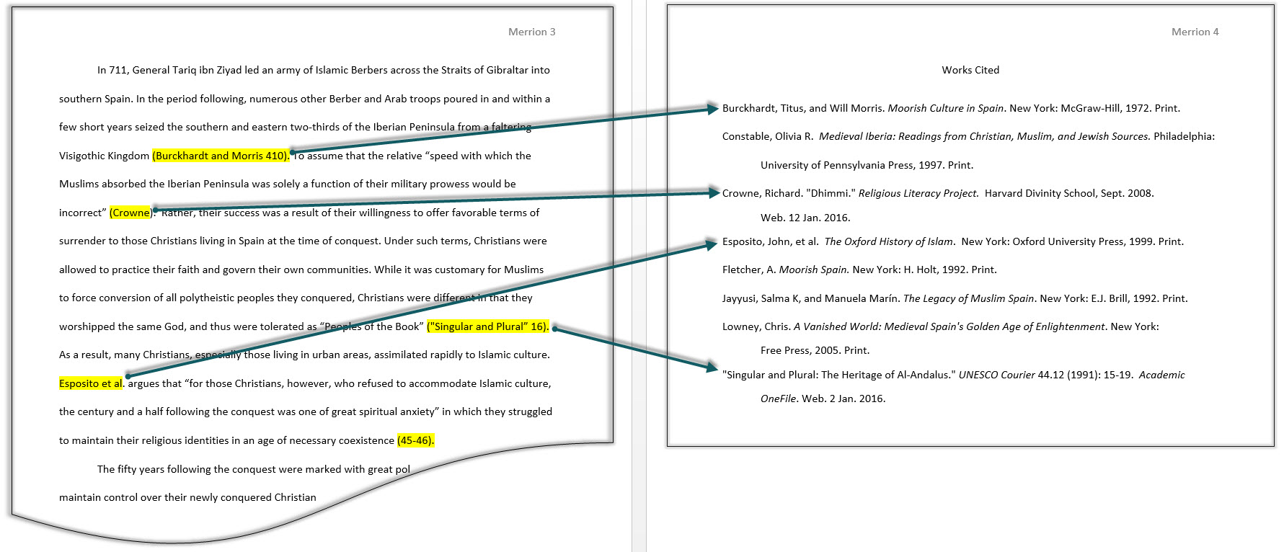
SCIENCE FAIR
Step 3 of the Scientific Method

FORM A HYPOTHESIS
Once you have done at least most of your research and you pretty much know what you want to do for an experiment, you are ready to make your “educated guess” about what will happen. Remember that it is all right if your hypothesis turns out to be wrong! You just state that in your conclusions and suggest a different hypothesis you would use if you were going to do another experiment.

A hypothesis may be worded in more than one way, but it must be specific about what you think will happen when you do a certain thing. Also, remember to write it in 3rd person, not 1st.

Example 1:
If you want to study the effect of water on plant growth, don’t just write, “Water affects how plants grow,” or “Water makes plants grow better.” Instead, write, “If different plants are given different amounts of water every other day, then the plants given the most water will grow the fastest.”
Or you could write, “Plants given more water every other day will grow the tallest.”
These last 2 hypotheses tell what you are going to do to the plants as well as what you predict will happen.

Example 2:
If you want to study whether certain substances can block a magnet’s attraction to iron nails, don’t write, “A magnet cannot attract an iron nail if an object is in the way,” or “If I put something between a magnet and a nail, nothing will happen.” Instead, write, “If a 2-mm-thick piece of cardboard, or paper, or Styrofoam, or plastic is put between a magnet and an iron nail, then the magnet will not attract the nail.”
Of you could write, “Putting a 2-mm-thick piece of cardboard, paper, Styrofoam, or plastic between a magnet and an iron nail will prevent the magnetic attraction.”
Again, the last 2 hypotheses tell what you are going to do to the nail and magnet as well as what you predict will happen. Also, the 2nd “bad” example above is written in 1st person, which it should not be.

Your hypothesis is due on Monday, 11/25/19 (at the latest), and is worth 15 points.

SCIENCE FAIR
Step 4 of the Scientific Method

TEST THE HYPOTHESIS (the experiment)
Design an experiment that will test your hypothesis. Make sure you have only 1 independent variable at a time (the variable you will control) and 1 or no more than a few dependent variables (the variables you will measure); the more variables you have, the harder your experiment will be to both do and to analyze.

For example, in the plant-water experiment, the independent variable would be the amount of water you give to each plant on which days. The dependent variable(s) could be the height of the plants on different days and how many leaves each plant has. In the magnet experiment, the independent variable would be the type or thickness of the substance you put between the magnet and the nail. The dependent variable would be whether or not the magnet attracts the nail through the blocking substance. Do not vary both the type of substance and the thickness of the substances in the same trial because that would be 2 independent variables.

Testing the hypothesis will fill three sections in your science fair report and display: “Materials,” “Procedure,” and “Data” (also called “Results” or “Observations”).

- Materials—The Materials section will be a list of what you need to use for your experiment—the equipment or tools you will use (such as a timer, ruler, measuring cup, etc.) plus the things you will “use up” (such as soil, water, fertilizer, tape, etc.) Make sure you include how much of everything you need.

- Procedure—The Procedure section will be a numbered list or a paragraph describing each step in your experiment, from setting it up to the very end. (It’s easier to write a numbered list.) It should be detailed enough that someone can reproduce your experiment by following the steps you list. You may include a drawing or photograph to make the procedure clearer, if you wish.

- Data (or Results or Observations)—The Data section will be all the results of your experiment: any written descriptions of what happened, any drawings or photographs you made, any measurements, etc. ALL observations, measurements, drawings, photographs, etc. must be dated and recorded in your daily log (composition notebook). Photographs should not show faces or any other identifying information. All, or at least the important parts, of the data will also be included in the final science fair report and will be displayed on the display board. All measurements should be in metric, or SI, units: g or kg for mass/weight; mm, cm, m, or km for length or height; mL, cL, dL, or L for volume; ºC for temperature.
NOTE: You may want to combine the data and data analysis in a single section in your final science fair report, called “Data & Analysis.”

The materials and procedure are due before you begin your experiment so I can help you if you’re not on the right track. Remember that you may turn them in before the due date if you want to get started on the experiment. The data are not due before the science fair. The Data and Analysis sections will be graded together.

Due Date Points
Materials Friday, 12/13/19 20
Procedure Friday, 12/13/19 25

Data + Analysis Friday, 1/24/20 20

SCIENCE FAIR
Step 5 of the Scientific Method

ANALYZE THE DATA
Your data will consist of numbers or observations you have written down, and any drawings or photographs you made. To analyze the data, you may be able to calculate means (averages) or percentages. You will also organize the data into 1 or more tables, and/or 1 or more graphs. In addition, you must include a written analysis that explains and describes the tables, graphs, drawings, and photographs, otherwise the reader won’t know how to interpret your tables, etc.

MOST students will be able to make a table and a graph, but sometimes the data can’t be put into a table or graph. It all depends on what kinds of observations or measurements you make.

In your final science fair report and on your display, you may combine the Data and Analysis into one section called “Data & Analysis,” if you wish.

Data & Analysis is due with the rest of the final report, on Friday, 1/24/20, and it is worth 20 points.

---------------------------------------------------------------------------------------------------------------------
EXAMPLES OF MEANS, TABLES, AND BAR & LINE GRAPHS
Let’s say you measure the height of plants at times 0, 1, 2, and 3 weeks. You give each plant 0, 25, or 50 mL of water every other day. Each group of plants (the 0-mL group, the 25-mL group, and the 50-mL group) contains 3 plants. A sample table showing the measurements is below.

TABLE 1—PLANT HEIGHTS
(Notice that the table has a title and lists the units.)
AMOUNT OF PLANT HEIGHT (cm)
WATER (mL) 0 WEEKS 1 WEEK 2 WEEKS 3 WEEKS
0 10 12 14 14
9 12 13 13
12 13 14 14

25 9 16 21 25
11 16 20 25
11 17 21 24

50 12 17 20 22
8 14 17 19
11 16 19 21

Table 1 shows the heights of the plants at 0, 1, 2, and 3 weeks when the plants were given 0, 25, or 50 mL of water every other day. (Notice that this sentence briefly describes what is in the table.)

Remember that the mean = sum of all the measurements
total # of measurements
Example: The mean of 3, 4, 5, and 6 = 3 + 4 + 5 + 6 = 18 = 4.5
4

TABLE 2—MEAN PLANT HEIGHTS

AMOUNT OF MEAN PLANT HEIGHT (cm)
WATER (mL) 0 WEEKS 1 WEEK 2 WEEKS 3 WEEKS
0 10.3 12.3 13.7 13.7

25 10.3 16.3 20.7 24.7

50 10.3 15.7 18.7 20.7

Table 2 shows the mean heights of the plants at 0, 1, 2, and 3 weeks when the plants were given 0, 25, or 50 mL of water every other day. It can be seen that the plants grow the most when they receive 25 mL of water and the least when they receive no water. In fact, the plants with no water did not grow at all the 3rd week.

Notice that the graphs each have a title, and the axes are labeled and include units.

GRAPH 1—TOTAL MEAN PLANT HEIGHT (This is a bar graph.)

25_
Mean plant 20_
height after 15_
3 weeks (cm) 10_
5_
0______________________
0 25 50
mL of Water

Graph 1 shows the mean plant height after 3 weeks of receiving 0, 25, or 50 mL of water every other day. The plants receiving 25 mL of water grew the tallest.

GRAPH 2—HEIGHT OF PLANTS OVER TIME (This is a line graph.)
Mean plant
height (cm) 0 mL water, 25 mL water, 50 mL water
0 1 2 3 weeks
Mean Plant Height (cm)

Graph 2 shows how much the plants in each group grew over 3 weeks. It can be seen that plant growth slowed after the first week. The plants with no water did not grow at all after week 2.

---------------------------------------------------------------------------------------------------------------------
Remember that percent, % = the # in a category x 100%
total possible
Example: If 11 students out of a grade of 44 students earned an A on a test, the percent of A’s is 11 x 100% = (11 ÷ 44) x 100% = 0.25 x 100% = 25%
44

EXAMPLES OF PERCENTAGES & CIRCLE (OR PIE) GRAPHS
Let’s say you survey 200 junior high students to find out what their favorite pet is—dog, cat, fish, rabbit, or rodent (mouse, rat, hamster, Guinea pig). The results are shown in a table, as percentages, and in a circle graph.

TABLE 1—STUDENTS’ FAVORITE PETS

FAVORITE
PET NUMBER PERCENT

Dog 110 55%

Cat 60 30%

Fish 12 6%

Rabbit 10 5%

Rodent 8 4%
200 100%

Table 1 shows the number of junior high students choosing different animals as their favorite pet. The results are also shown as percentages.

GRAPH 1—STUDENTS’ FAVORITE PETS (This is a circle graph.)
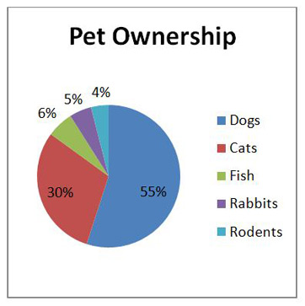

Graph 1 shows the percent of junior high students choosing different animals as their favorite pets.

SCIENCE FAIR
Steps 6-8 of the Scientific Method

STEPS 6-8 WILL BE INCLUDED TOGETHER IN THE “CONCLUSIONS” SECTION OF YOUR FINAL SCIENCE FAIR REPORT.

6. MAKE CONCLUSIONS
Write about what the tables, graphs, etc. tell people about your topic and your experiment. Try to explain why what happened did happen (you may speculate here). You can refer to your research (from your research paper) and how other people’s results compare to yours. If you think there were any sources of error in your experiment (and there always are!), discuss them here and describe what you could have done differently. If the results of your experiment may be important, relevant, or useful in daily life, discuss the importance in this section. Finally, include steps 7 and 8 below in the Conclusions section.

7. HYPOTHESIS ACCEPTED OR REJECTED
This is the most important part of your Conclusions section. State whether the hypothesis is accepted (because it is supported by the data) or rejected (because it is not supported by the data). If it was not supported, try to explain or speculate why. Do NOT change the hypothesis or leave out any data that do not support it. Hypotheses are often not supported and are then modified or thrown out. This is part of the scientific method and is done by professional scientists all the time.

8. RE-TEST, MODIFY, OR THROW OUT HYPOTHESIS
If you accept your hypothesis because it was supported by the data, suggest another possible experiment that could test it further because all hypotheses must be tested many times on their way to becoming part of a theory.

If you reject your hypothesis because it was not supported by the data, suggest a modified or new hypothesis that could be tested in the future.

The Conclusions section (including everything in steps 6-8 above) is due with the rest of the final report, on Friday, 1/24/20, and it is worth 20 points.

SCIENCE FAIR
Steps 9 of the Scientific Method

REPORT THE RESULTS
As part of the science fair project, you must report results in 4 different places—the daily log, the science fair report, the display, and the abstract. The display board is probably what you’re used to seeing at science fairs, but the other 3 parts are also required.

- The daily log—you have already been told about the daily log on pages 4-5 of this handout. It is recorded in your composition notebook and will be placed on the table in front of your display. It includes everything you do except the written research paper. The outside cover should have your assigned ID number; your name should not be written anywhere.

b) The science fair report—This is a long lab report, in a report cover, which is placed on the table in front of your display. Everything except the title page, tables, graphs, and pictures must be typed double-spaced in 12-point Times New Roman font, with 1-inch margins, on the left. Every section should begin on a new page. Everything except the title page should have the section name typed at the top. Here are the sections, in order.
i) Title Page—has the title of your science fair project and your assigned science fair number. School name and date of science fair are optional. (NO NAME, homeroom, grade, or anything else that could identify you to the general public). This is the only page that can be typed in larger than 12 point font. (1 page)
ii) Table of Contents—lists which sections are on which pages (1 page)
iii) Problem (or Question)—You already turned this in and had it approved. Make corrections if necessary. (1 or a couple of sentences)
iv) Research—This is the research paper you already turned in, with corrections made. (1-3 pages)
v) Hypothesis—You already turned this in and had it approved. Make corrections if necessary. (1 to a few sentences)
vi) Materials—a list of what equipment and materials you used, and how many or how much. You already turned this in and had it approved. Make corrections if necessary so that it matches what you actually used. (around 1 page)
vii) Procedure—a detailed description of what you did to test the hypothesis; may include a drawing or photograph if that will help the reader understand your procedure. You already turned this in and had it approved. Make corrections if necessary so that it matches what you actually did. (1-2 pages)
viii) Data (or Results or Observations)
ix) Analysis
NOTE: You may want to combine viii and ix into one section called Data & Analysis. [around 1-2 written pages + table(s), graph(s), and/or picture(s)]
x) Conclusion (½ - 1 page)
xi) Bibliography (or References or Works Cited)—a list of the books, articles, websites, people, etc., that you used in your research paper. You already turned this in and had it approved, but now move it from the end of your research paper to the end of the science fair report. Make corrections if necessary. (at least 3 sources; at least 5 for the regional science fair)

c) The display—The display is mounted on a 36” x 48” tri-fold display board. The title must be on the board; if you have an optional header, the title goes on the header. You will be able to place an optional order with your teacher for a display board with a header and labels for the sections. The cost is $10.

The display must have the title (on the header if you have one), problem, hypothesis, materials, procedure, data & analysis (tables, graphs, photos, descriptions, etc.), conclusion, and bibliography. You may also include other categories if you wish and if they fit (such as research, application, or recommendation). If you buy the section titles, there will be some you will not use.

You will be given a sticker to place on the upper right hand corner of your header (or the board if you have no header) on which you will write your science fair ID number. The sticker color will indicate to which category your project is assigned. NO NAME!

Here are two sample displays. On the table in front of the display board, you will have your daily log, the science fair report, the abstract, and any model or sample you want to display. However, remember that people will be touching your models and samples. Where sections go on the board doesn’t matter as long as everything fits and makes sense.

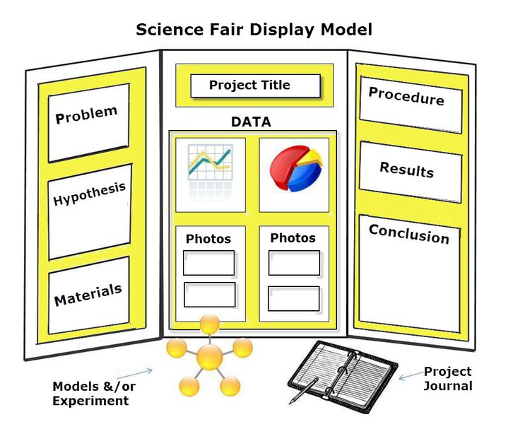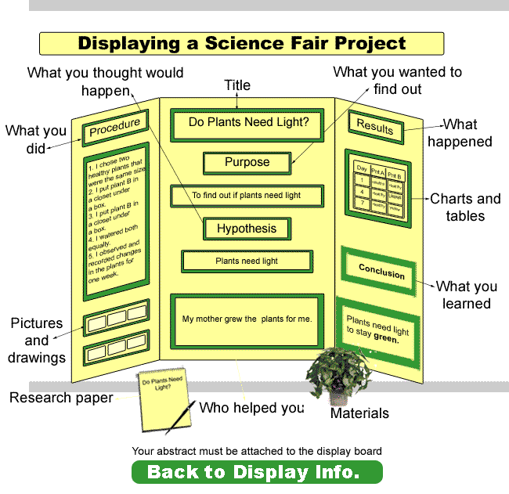

d) The abstract—The abstract is a summary of the science fair report that is no more than 1 page long double-spaced. It includes a summary of every part of the science fair report. It also has your assigned ID number at the top. (NO NAME) The abstract will be on the table in front of your display board.

The complete science fair project—the daily log, science fair report (including parts that have already been turned in and graded), display, and abstract—is due Friday, 1/24/20. We will set them up in the cafeteria after lunch. The projects will be previewed by the science teacher on Friday, officially judged on Saturday, and viewed by the public on Sunday, 1/26/20. Students are not present during the judging. The science fair is open to students, parents, and the public only on Sunday.

Here is a list of the remaining points.

Due Date Points
In written report: Friday, 1/24/20 10
Title Page
Table of Contents
Corrections made to already-graded parts
Display Friday, 1/24/20 75
Abstract Friday, 1/24/20 10
Overall format Friday, 1/24/20 5

Overall format includes odds and ends such as setting up your display in the correct category, having the correct ID number on it and in the correct locations, not having a name anywhere, and other following-instructions types of things.

You may also earn up to 5 points of extra credit for “extras” added to the display—models, plants, decorations, etc.

